**CS 492**

**Senior Design Project**

**2022 Spring**



**User Manual**

**PolliVidis**

Ömer Ünlüsoy - 21702136

Elif Gamze Güliter - 21802870

İrem Tekin - 21803267

Ece Ünal - 21703149

Umut Ada Yürüten - 21802410

**Supervisor**: Ercüment Çiçek

**Jury Members**: Shervin Arashloo and Hamdi Dibeklioglu

This report is submitted to the Department of Computer Engineering of Bilkent University in partial fulfillment of the requirements of the Senior Design Project course CS491/2.

Table of Contents

1. About Installation 3

2. Pollen Map 3

3. Registration (Sign Up) 4

4. Academic Login 5

5. Navigation Menu without Academic Login 6

6. Navigation Menu with Academic Login 7

7. Analyze Sample Page 7

7.1 Upload Image Page 9

7.2 Analysis Report Page 9

8. Previous Analyses Page 10

9 Profile Page 11

10 About Us Page 12

11 Download Dataset Page 13

12 Feedback Page 13

13 How PolliVidis Works Page 14

# 1. About Installation

PolliVidis does not require any installation since it is a web application. Anyone with an internet connection and website address can use PolliVidis.

# 2. Pollen Map

This is the page when users enter the PolliVidis webpage. It shows the pollen map which contains pollen analysis of specific locations. There are mini red microscope icons on the pollen map. These icons work as a button and if the user pushes one of them, he/she can see the pollen analysis made by academics on that location.

There is a red button “Filter” on the left side of the main page, by using this button, any user can see the location of a special pollen. For example, if they filter the name “Populus nigra”, they will only see the locations of Populus nigra pollens in the map.

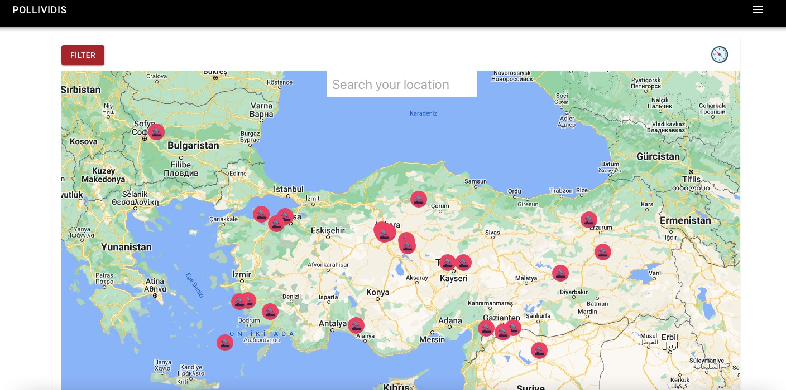

Figure 13: Pollen Map

# 3. Registration (Sign Up)

If a user presses the academic login button in the navigation menu, the login page will be open. There is a “Sign Up” button in that page which will direct the unregistered user to the Registration Page. In the Registration Page, academic users will be signed up to the PolliVidis by their name, appellation, institution, email and a safe password.

Users need to register by using a unique email address, previously used email addresses are not allowed. For the safety issues, all registered users need to be academics, therefore, academicians have to give the name of the institution that they work in order to validate their registration request.

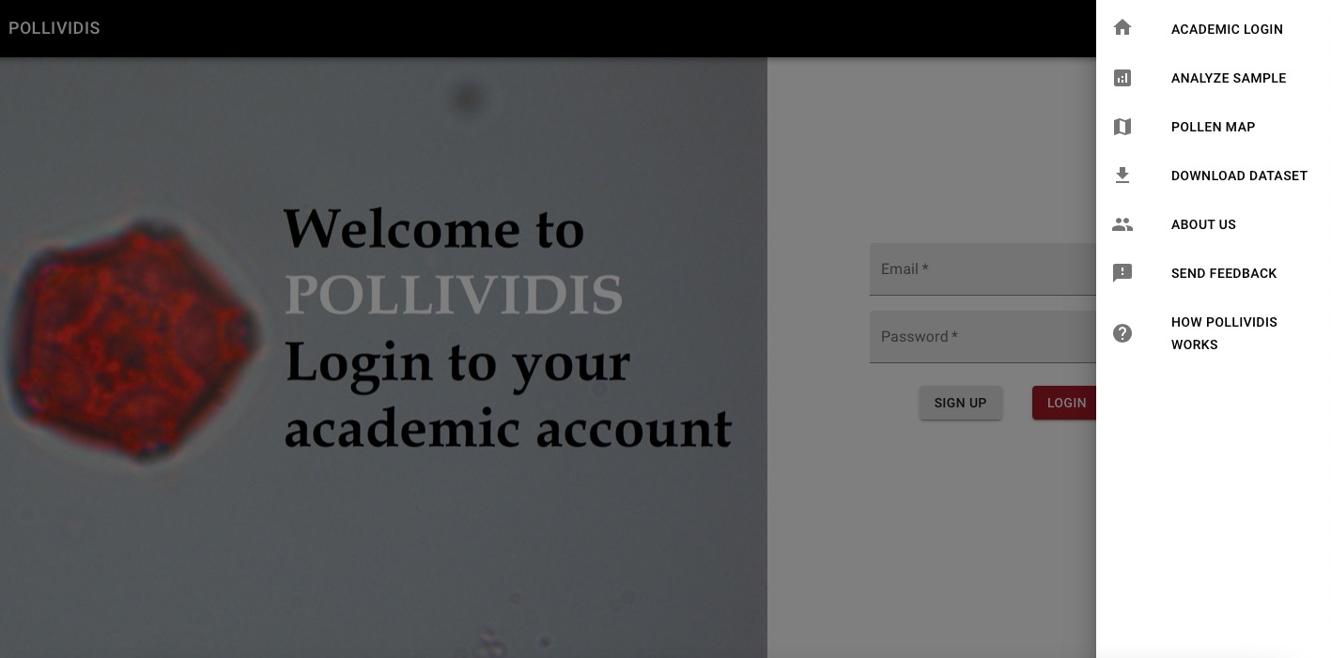

Figure 14: Menu Bar

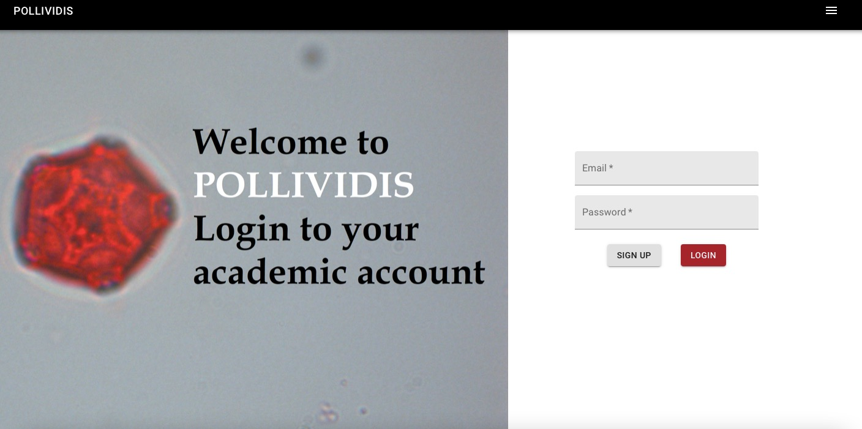

Figure 15: Login

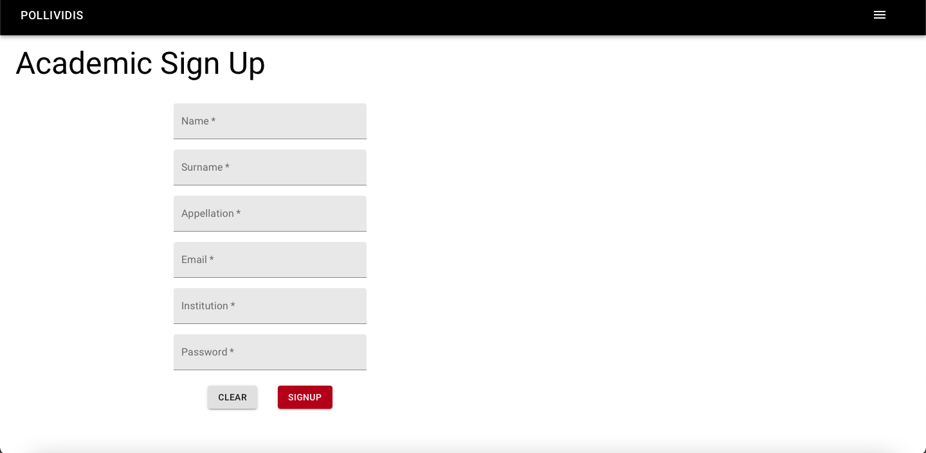

Figure 16: Academic Sign Up

# 4. Academic Login

In order to add analysis to the pollen map, or look back to their previous analysis, academics have to login from the academic login page. Below is the academic login page where they can login by their academic email and password.



Figure 17: Academic Login

# 5. Navigation Menu without Academic Login

Actions of a non-academic user is limited in PolliVidis. The user can analyze a pollen sample, look at the pollen map but cannot add anything to the pollen map. Below is the left navigation menu in PolliVidis without any login.

Users without an academic login can also send feedback to developers, see informative pages such as “How PolliVidis Works” and “About Us”.



Figure 18: Navigation Menu Bar without Login

# 6. Navigation Menu with Academic Login

Below is the navigation menu after academic login. In that menu, academic users can see their profile from the “Profile” button, see their previous analyses by the “Previous Analyses” button and log out by the “Logout” button.

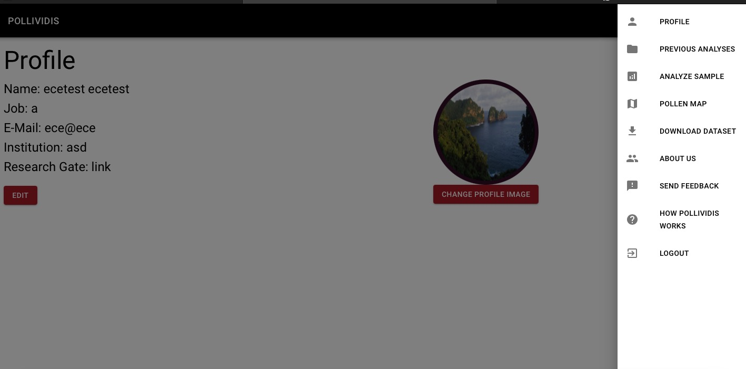

Figure 19: Navigation Menu Bar with Login

# 7. Analyze Sample Page

In order to analyze a sample, users should press the “Analyze Sample” button in the navigation menu. After pressing the button, the Analyze Sample page will be open. In that page, there are option buttons in the upper left corner. By using the “Upload Sample Image” button, users can upload any pollen image from their local device.

There is a Morphology Sequence box with the default value 10. This input is for erosion and dilation settings in pollen image processing, on average using the value ten gives good results, however; users can change it.

There is a “Get My Location” button next to the Morphology Sequence box. This button is used to get the user's location automatically in order to save the analysis in a pollen map. However, users can also give any location by pressing on that location in the pollen map.

After all the required inputs are given, the user needs to press “Analyze” button and wait for machine learning algorithm to analyze the sample.

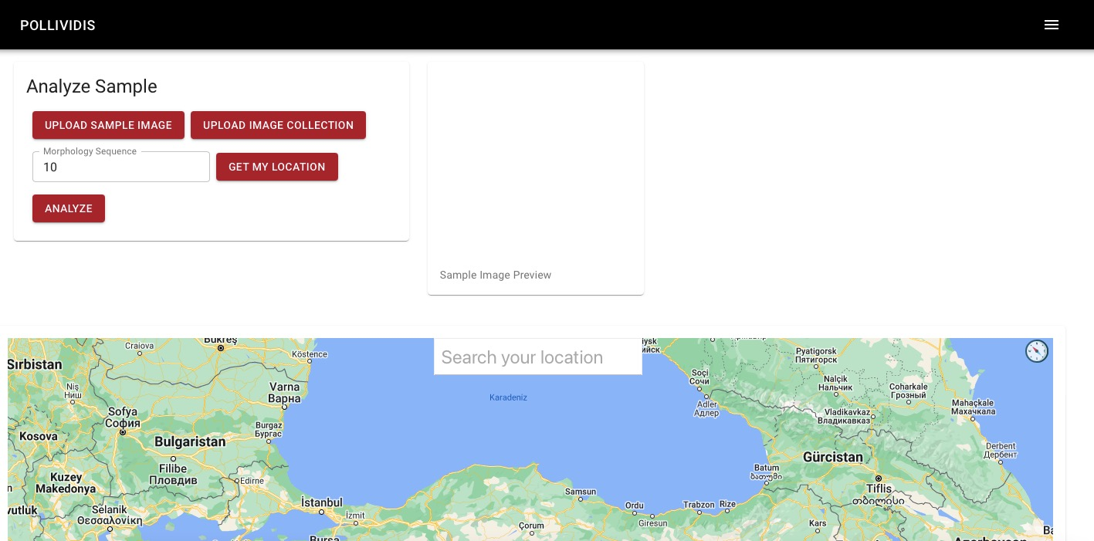

Figure 20: Analyze Sample

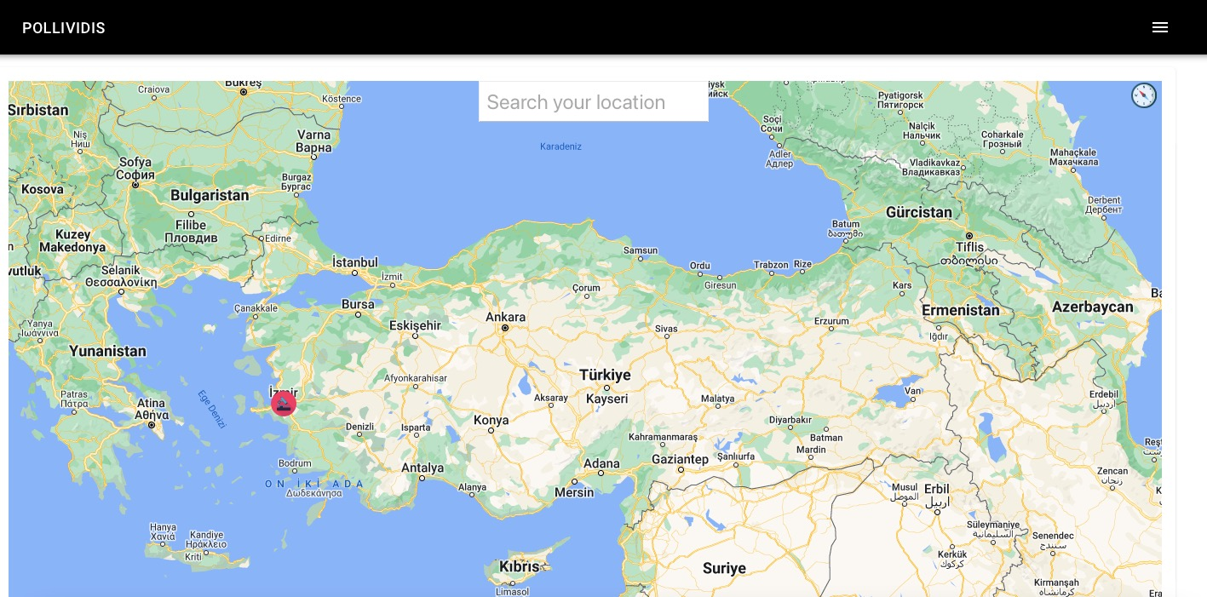

Figure 21: Analyze Sample Location

## 7.1 Upload Image Page

When users press the “Upload Sample Image” button in the Analyze Sample page, the Upload Image Page opens. From this page, users can browse through their local device and upload a pollen image from there in order to analyze it.

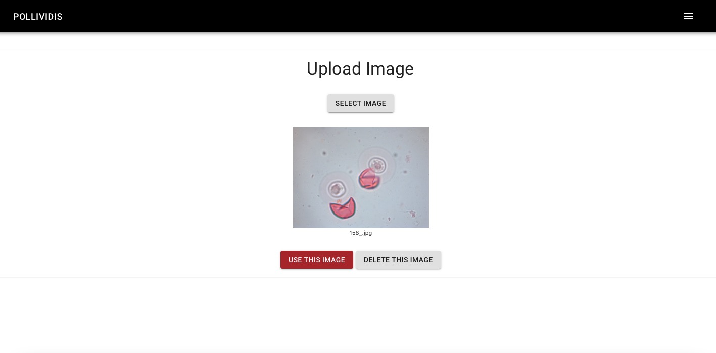

Figure 22: Analyze Sample Upload Image

## 7.2 Analysis Report Page

After the user gives the required information and presses the “Analyze” button, the related Analysis Report page opens. From this page, users can see the classified pollen that the sample contains and the other details such as date and location of analysis.

In the example below, the algorithm classified the pollen samples as juniperus_communis pollens, date is May 2 2022, Monday.

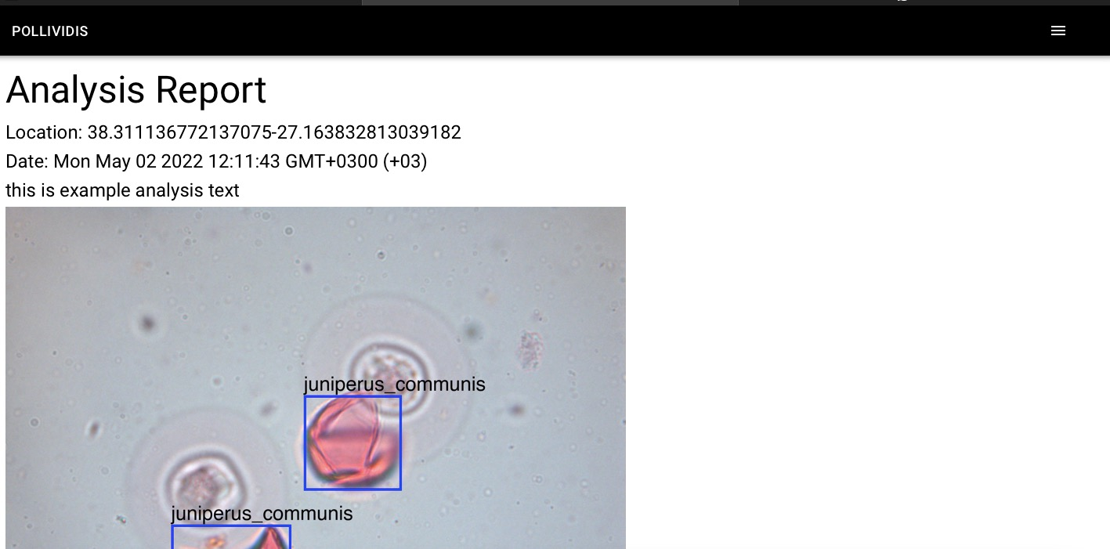

Figure 23: Analysis Report

# 8. Previous Analyses Page

Academic users can also see their previous analyses from the “Previous Analyses” button in the navigation menu. After pressing the button, the Previous Analyses page opens. In this page all the analyses made by the user are listed by their date and location. Users can see the details of them by pressing the “View” buttons on the right side of each analysis. After pressing these buttons small windows which contain information of that analysis will be open.



Figure 24: Navigation Menu Bar

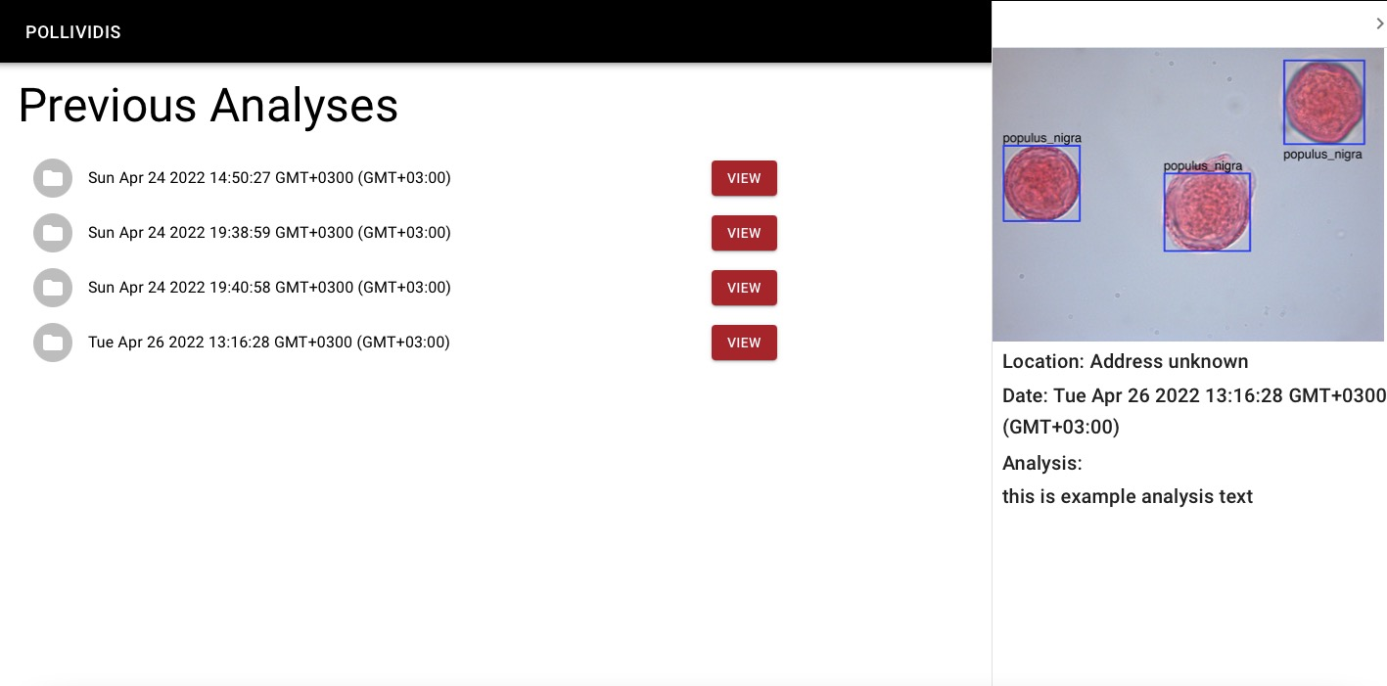

Figure 25: Previous Analysis Table

# 9 Profile Page

Academic users can see and edit their profile information from the Profile button in the navigation menu. After pressing the button, the profile page of the user will be open. From the profile page, users can edit their personal information and change their profile picture. In order to upload a new profile picture, users need to press the “Change Profile Picture” button and choose a picture from their local device. In order to edit their personal information, users need to click the edit button on the left side.



Figure 26: Navigation Menu Bar

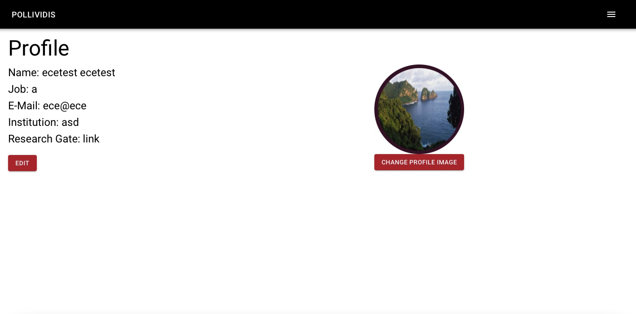

Figure 27: Profile

# 10 About Us Page

In order to see credentials of developers, users need to click on the “About Us” button in the navigation menu.

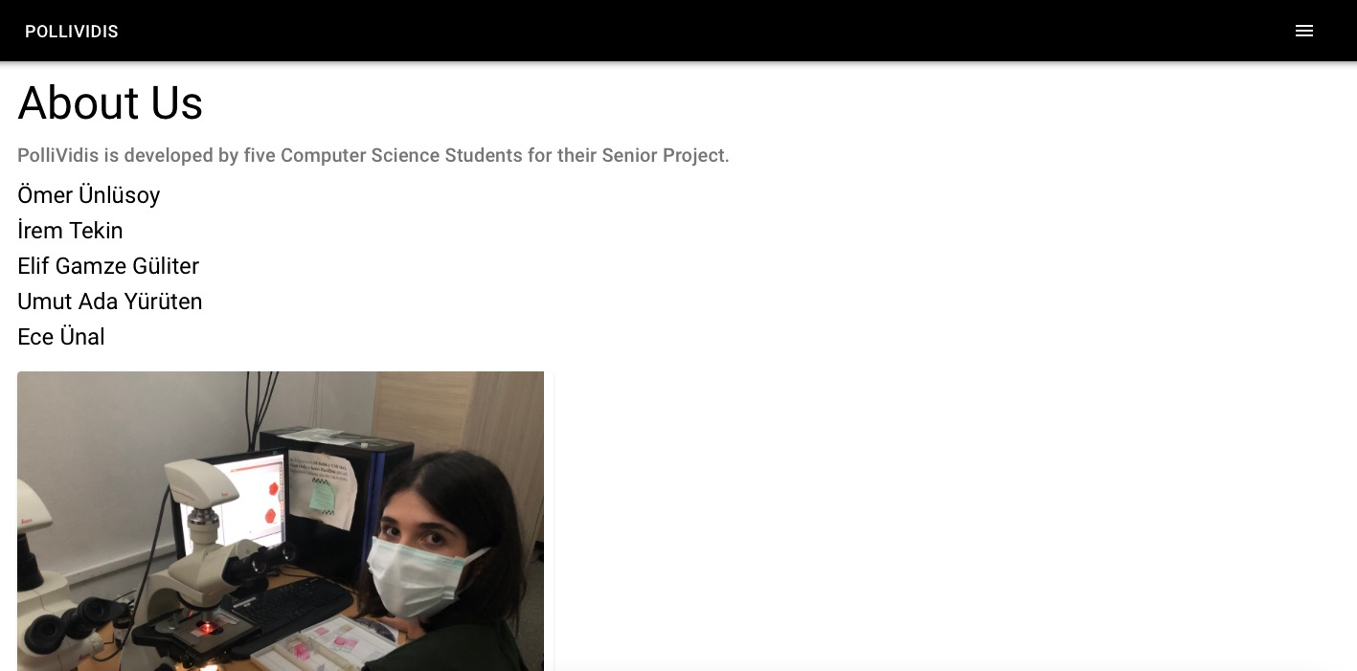

Figure 28: About Us

# 11 Download Dataset Page

In order to download the dataset collected by us, users can press the Download Dataset button in the navigation menu. In that page, there is a link for users to press in order to download the dataset.

Note for the users: Currently, dataset is not available as PolliVidis team plans to write the article of this project and the dataset will be published afterwards. For more information, contact any team member.

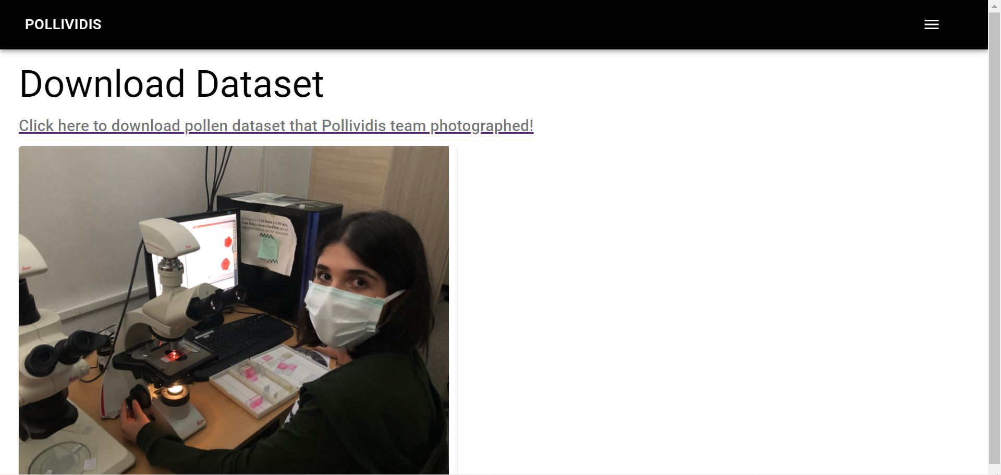

Figure 29: Download Dataset

# 12 Feedback Page

Users can give feedback to developers from the Send Feedback button in the navigation menu. In that page, they can share their opinions about PolliVidis with their names and email addresses.

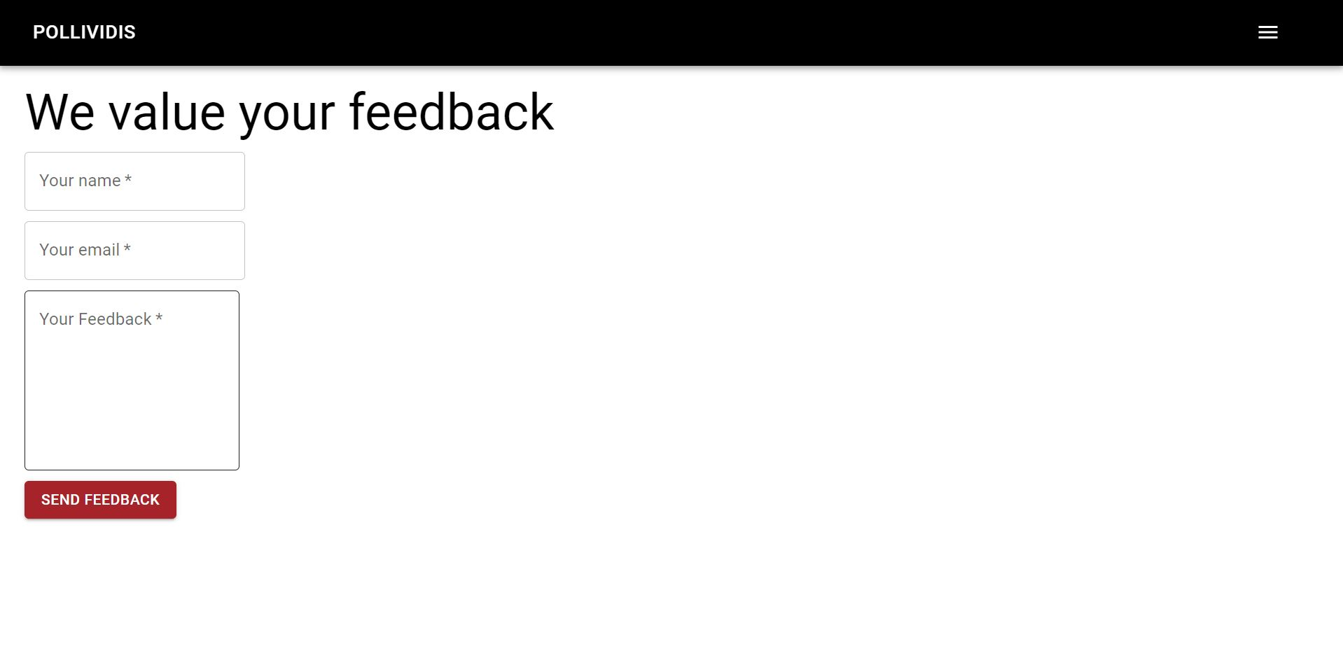

Figure 30: Feedback

# 13 How PolliVidis Works Page

In order to see how PolliVidis works, users can press the How PolliVidis Works button in the navigation menu.

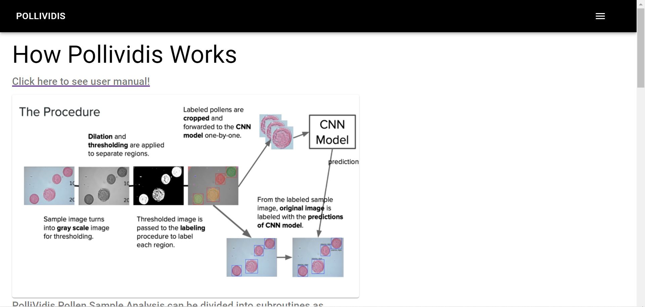

Figure 31: How PolliVidis Works?